PHYSICS PROJECT REPORT

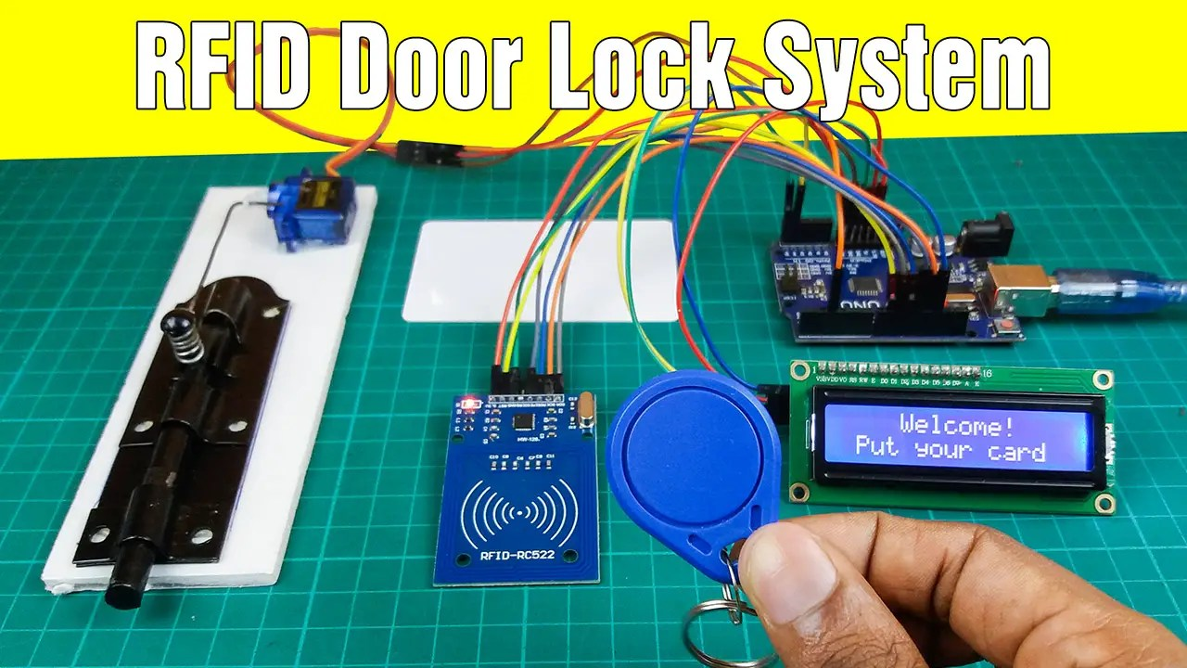
Prepared by the team:
- Prapti Chavan
- Ananya Kulkarni
- Pawani Joshi
- Anjishnu Ghosh
- Anuj Pagare

RFID DOOR LOCK SYSTEM
RFID DOOR LOCK SYSTEM
Enhancing Security Through Contactless Authentication
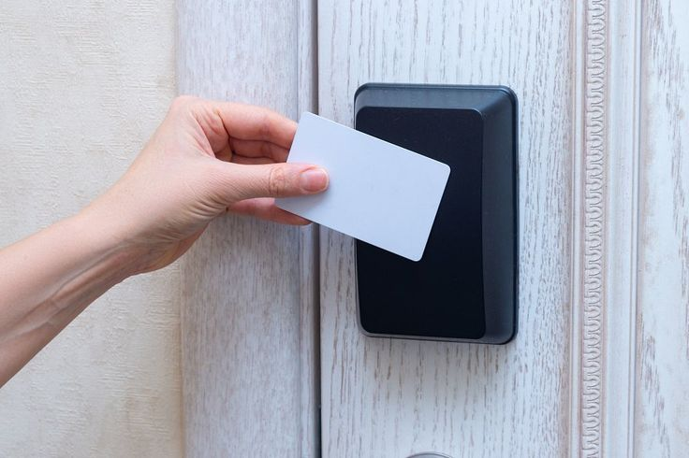
Radio Frequency Identification (RFID) is a wireless technology that allows data to be read from a tag using radio waves, without the need for physical contact. Because of its speed, reliability, and ease of use, RFID has become a popular choice for modern security systems.
An RFID Door Lock System uses this technology to provide controlled and secure access. When an RFID card or tag is brought near the reader, it transmits its unique identification number. The system checks this ID against stored authorized entries, and if it matches, the door unlocks automatically. This makes the system more convenient than traditional keys, reduces the risk of unauthorized access, and is widely used in offices, hostels, smart homes, and industrial areas.
Physics in the RFID Door Lock Project
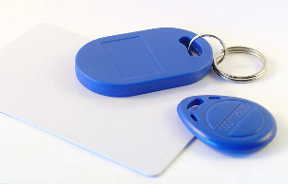
1. Electromagnetic Induction (RFID Reader & RFID Tag/Card)
The RFID reader generates an electromagnetic field.
When the RFID tag/card comes near it, this changing magnetic field induces a small electric current inside the tag’s coil.
This is based on Faraday’s Law of Electromagnetic Induction, which allows the tag to power up and transmit its unique ID.
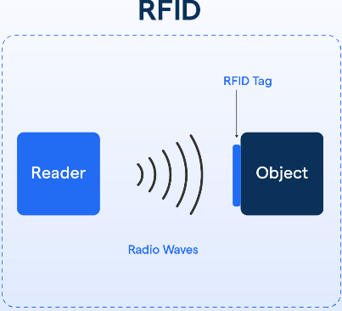
2. Radio Frequency Waves (Communication Between Reader & Tag)
The data from the tag is sent through radio-frequency electromagnetic waves.
These waves travel through the air without any physical contact, demonstrating concepts of:
- Wave propagation
- Frequency
- Signal transmission
This is the core physics principle behind wireless communication.

3. Electromagnetism in Digital Switching (Arduino & Relay/Lock)
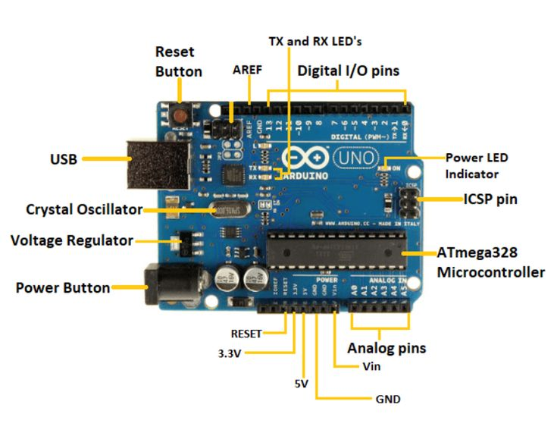
When the Arduino verifies the tag, it sends an electrical signal to the lock/relay.
This involves:
- Current flow
- Voltage control
- Magnetic actuation (if an electromagnetic lock is used)
This shows how electrical energy is converted into mechanical action using electromagnetism.

4. Energy Transformation
Multiple energy conversions happen inside the project:
- Electrical energy → Electromagnetic energy (inside the RFID reader)
- Electromagnetic energy → Electrical energy (inside the tag)
- Electrical signals → Digital decisions (in Arduino)
These transformations reflect basic physics principles.
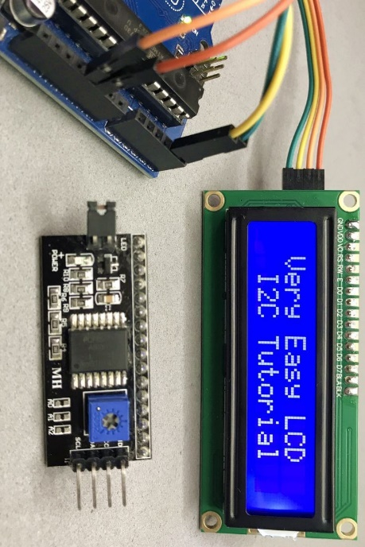

5. Light and Optics (LCD Display)
The LCD display uses:
- Liquid crystal alignment controlled by electric fields
- Backlight illumination
This involves physics concepts such as polarization and light modulation.

5. Electromagnetism in Servo Motor (Door Lock Movement)
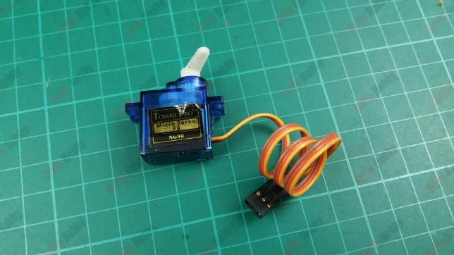
The servo motor converts electrical signals into controlled mechanical motion.
Inside a servo:
- Coils create a magnetic field when current flows
- The magnetic field interacts with permanent magnets
- This interaction produces torque, causing rotation
- The motor turns to a specific angle using Pulse Width Modulation (PWM) signals from Arduino
Physics involved:
- Electromagnetism (current → magnetic field → rotation)
- Torque and rotational motion
- Angular displacement
- Conversion of electrical energy to mechanical energy
This allows the door lock to open and close smoothly.

CIRCUIT DIAGRAM

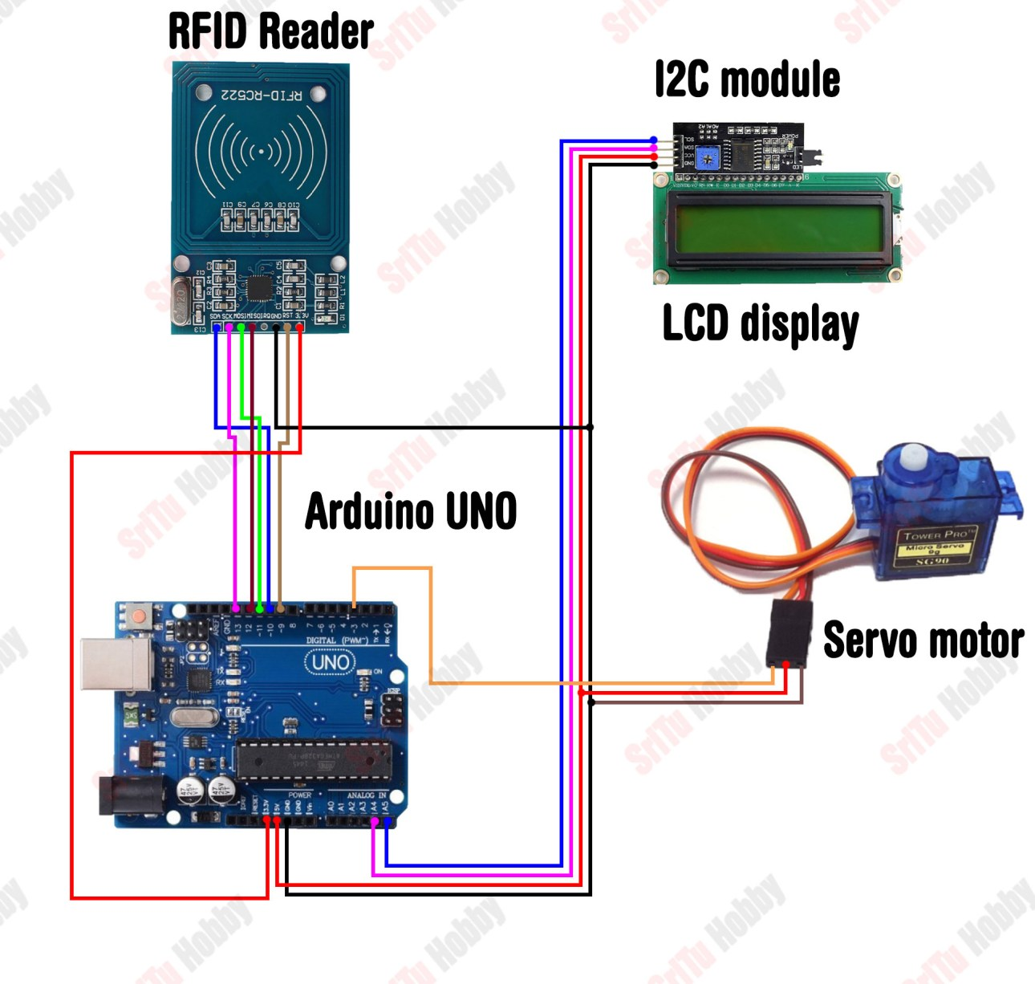

WORKING
HOW THE SYSTEM WORKS (Step-by-Step Explanation)

STEP 1: RFID reader creates an electromagnetic field
- The RC522 constantly emits radio waves.
- When an RFID card comes near it, energy is transferred wirelessly.

STEP 2: Tag sends its UID (unique ID)
- The tag/card receives energy and sends its unique ID number back to the reader.

STEP 3: Arduino receives the UID
- Through SPI pins, the Arduino reads the card’s UID.

STEP 4: Arduino checks if UID is authorized
- Inside your Arduino code, you store the authorized card numbers.
- Example:
- if (UID == "XX YY ZZ") // authorized

STEP 5: LCD displays message
- Based on the UID match:
- ✔ If authorized
- LCD shows "Access Granted"
- Servo rotates to open the lock (90°)
- ❌ If unauthorized
- LCD shows "Access Denied"
- Servo stays in locked position (0°)

STEP 6: Servo motor controls the lock
- Servo rotates according to the Arduino’s command.
- This rotation moves the lock latch → door opens or stays locked.

STEP 7: System resets
- After a delay, servo returns to locked position and waits for next scan.

CIRCUIT CONNECTIONS
1. RFID Reader (RC522) → Arduino UNO
- The RFID module usually has these pins:
VCC, RST, GND, MISO, MOSI, SCK, SDA
- Connections
- RFID Pin | - Arduino Pin | - Why this connection is needed
- VCC | - 3.3V | - RFID reader runs on 3.3V only, NOT 5V.
- GND | - GND | - Common ground so they share the same reference voltage.
- SDA | - D10 | - SPI communication chip select (lets Arduino pick the device).
- SCK | - D13 | - Clock signal for SPI communication.
- MOSI | - D11 | - Arduino → RFID data line.
- MISO | - D12 | - RFID → Arduino data line.
- RST | - D9 | - Used to reset the RFID module.
- Why these connections?
- The RFID uses SPI communication protocol, which requires SCK, MOSI, MISO, SDA pins.
- Arduino sends and receives data using SPI to read the tag’s ID.
- 3.3V power is needed because RC522 is sensitive and will get damaged at 5V.

2. I2C LCD Display → Arduino UNO
- Your display has an I2C module, so it only uses 2 wires instead of 12.
- Connections
- I2C LCD Pin | - Arduino Pin | - Why
- VCC | - 5V | - LCD needs 5V to power the backlight.
- GND | - GND | - Common reference for the circuit.
- SDA | - A4 | - I2C data pin—used to send characters to LCD.
- SCL | - A5 | - I2C clock pin—keeps timing for data communication.
- Why these connections?
- I2C communication uses only two wires (SDA + SCL).
- Arduino has dedicated I2C pins (A4 & A5).
- LCD displays everything Arduino wants to show like:
“Access Granted”, “Access Denied”, Tag ID”, etc.

3. Servo Motor → Arduino UNO
- Servos have 3 wires:
Brown/Black = GND
Red = VCC (5V)
Orange/Yellow = Signal
- Connections
- Servo Pin | - Arduino Pin | - Why
- VCC | - 5V | - Servo needs 5V to rotate.
- GND | - GND | - Common ground with Arduino.
- Signal | - D6 (or any PWM pin) | - PWM signal controls servo angle (0°/90°).
- Why these connections?
- The servo moves to a certain angle using PWM pulses from Arduino.
- For example:
- 0° = Door Locked
- 90° = Door Open
- Servo physically moves the latch of the door lock.

4. Jumper Wires
- These wires act as electrical paths connecting:
- Power (5V and 3.3V)
- GND lines
- Communication lines (SPI / I2C / PWM)
- Why needed?
- They form the complete circuit by linking every module to the Arduino.

Flowcharts
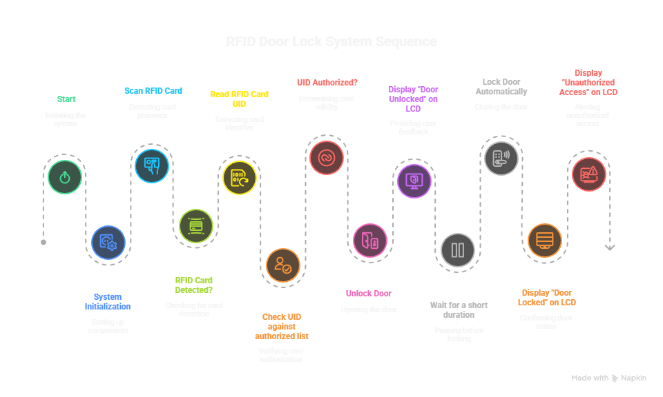

RFID Tag Scan Code Explanation:
This program uses an RC522 RFID reader to scan the UID of an RFID card and display it on a 16×2 I2C LCD and the Serial Monitor.
The RFID reader communicates with the Arduino through SPI, while the LCD uses I2C.
Required Libraries
Install these via Arduino Library Manager:
- MFRC522 → for RFID reader
- LiquidCrystal_I2C → for I2C LCD
- SPI → built-in, no download needed
How the Code Works
- Initializes LCD, SPI, and RFID reader.
- Shows “Put your card” on the LCD.
- Waits until a new RFID card is detected.
- Reads the card’s 4-byte UID.
- Displays the UID on:
  - LCD (in HEX form)
  - Serial Monitor
- Halts the card so it’s not scanned repeatedly.
Overall Summary
The code simply detects an RFID card, reads its unique ID, and prints it—forming the core part of an RFID door lock system, where this UID is later used to decide whether to unlock the door.

RFID Door Lock System — Code Explanation
This program reads an RFID card’s UID and uses a servo motor to lock or unlock a door based on whether the scanned UID matches the authorized UID stored in the code.
How It Works
- Setup:
  - Initializes LCD, servo, SPI, and RFID reader.
  - Sets servo to the default locked position.
- Main Loop:
  - LCD shows “Welcome – Put your card”.
  - Waits for a new card; reads its UID when detected.
  - Converts the UID to a string.
- Decision:
  - If scanned UID = stored UID:
    - If door is locked → unlock it using servo.
    - If door is unlocked → lock it back.
  - If UID does not match → display “Wrong card!”.
Summary
The code simply scans a card, checks if it matches, and then moves the servo to lock or unlock the door while showing status messages on the LCD.

Real Life Applications
- High-Security Server Rooms
RFID locks ensure only authorized staff enter; every access is logged for audits and cybersecurity compliance.

- Research Labs & Restricted Zones
Used to control entry to chemical labs, medical labs, and clean rooms where only trained personnel can enter.

- Multi-Level Access in Smart Buildings
Different employees get access to only specific floors or rooms based on their role or time of day.

- Two-Factor Entry Systems (RFID + Biometrics)
Critical areas like data centers require RFID plus fingerprint/face recognition for extra security.

- Emergency Unlock Systems
RFID doors automatically unlock during fire alarms or power failures to allow safe evacuation.

- Industrial & Hazardous Areas
RFID controls entry to machines, high-voltage rooms, or areas where safety training is mandatory.

- Police Evidence Rooms
Only authorized officers can unlock doors, with every entry timestamped for legal chain-of-custody.

- Hotels with Temporary Access Cards
RFID room keys expire automatically after checkout—reducing risk of unauthorized entry.

- Smart Apartments & Homes
Keyless RFID door locks provide convenient and secure home entry without physical keys.

- Automated Gate Systems for Vehicles
RFID tags on vehicles allow secure entry into parking lots, factories, and logistics hubs.

KEY TAKE AWAYS


Key Takeaways
- RFID enables fast, contactless authentication, making it suitable for secure access control.
- Strong hardware–software integration is essential, as sensors, controllers, actuators, and displays must work in sync.
- Correct power and wiring matter—wrong voltages or loose connections can damage modules or cause failures.
- Different communication protocols (SPI for RFID, I2C for LCD) must be understood to avoid conflicts and simplify design.
- UID-based security is basic; advanced systems require encryption, cryptographic tags, or multi-factor authentication.
- Fail-safe vs. fail-secure behavior must be considered for safety during power failures.
- Clear user feedback (LCD, LEDs, buzzer) improves usability and reduces errors.
- Prevent repeated or accidental scans using anti-repeat logic and proper tag handling.
- Error handling is crucial for unreadable tags, low power, or communication issues.
- Logging events improves accountability and system monitoring.
- Scalability requires proper credential management, revocation, and database support.
- Physical security is as important as digital—protect wiring and detect tampering.
- Testing and calibration ensure reliable servo motion, read range, and response time.
- Power optimization helps in battery-based or remote installations.
- Ethical and privacy considerations should guide data storage and access.
- Future upgrades include encryption, centralized management, biometrics, NFC, and integration with larger security systems.
CONCLUSION
This project was not just about building an RFID-based door-lock system, but also about understanding the real challenges of hardware integration. Along the way, we discovered that components can be unreliable — our RFID module failed three times — which highlighted the importance of early testing. We also learned that knowing the correct communication protocols matters; our initial confusion about the LCD’s I2C module caused wiring issues, but once understood, it made the setup far more stable and efficient.
Frequent connection errors and wrong pin mappings improved our troubleshooting skills and taught us the value of proper grounding, datasheets, and systematic debugging. A major setback occurred when our fingerprint sensor failed at the last moment, forcing us to shift entirely to RFID. This experience taught us adaptability, quick decision-making, and the importance of having backup plans.
Overall, this project helped us grow both technically and practically. We gained hands-on experience in integrating multiple modules, handling hardware faults, and debugging complex circuits. More importantly, it strengthened our teamwork, problem-solving, and ability to deliver a working solution despite unexpected challenges. This journey has given us a deeper confidence in tackling future electronics and embedded-system projects.

